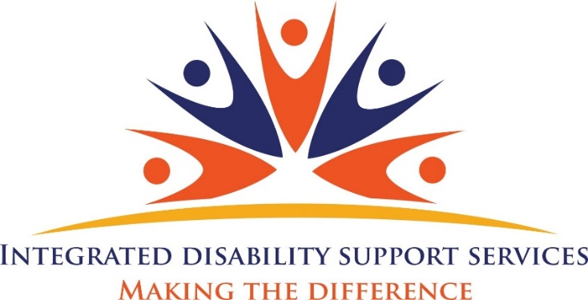

Welcome to IDSS

Our Vision
To close the gap and embrace
the most vulnerable members of our community, through building independence, empowering resilience and strengthening community linkages.

Our Mission
To make a difference by listening to the community, responding to individual needs and empowering success by working hard to reduce the stigma attached to the members of our community with a disability.

About IDSS

Life is a journey that can take many turns. We’re here to be with you on that journey.

We are committed to improving the lives of the people we support. We do this primarily through our person- centered approach, which puts people at the Centre of all our activity.

You may be looking for day to day support; a group or class to join for fun, fitness or friendships, transport to help you with getting out and about or professional support for the challenges that life can present.

We offer services that reach out, advocate, connect and inform.

We offer support around people’s needs, interests and issues.

We provide a range of programs and activities for families and individuals living in the community and we work with local people to promote a diverse, socially-just and inclusive community.

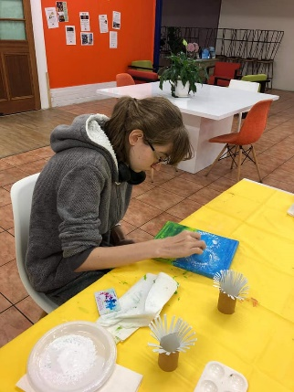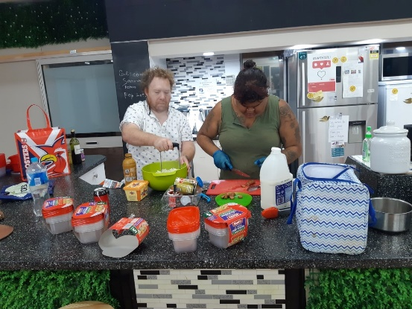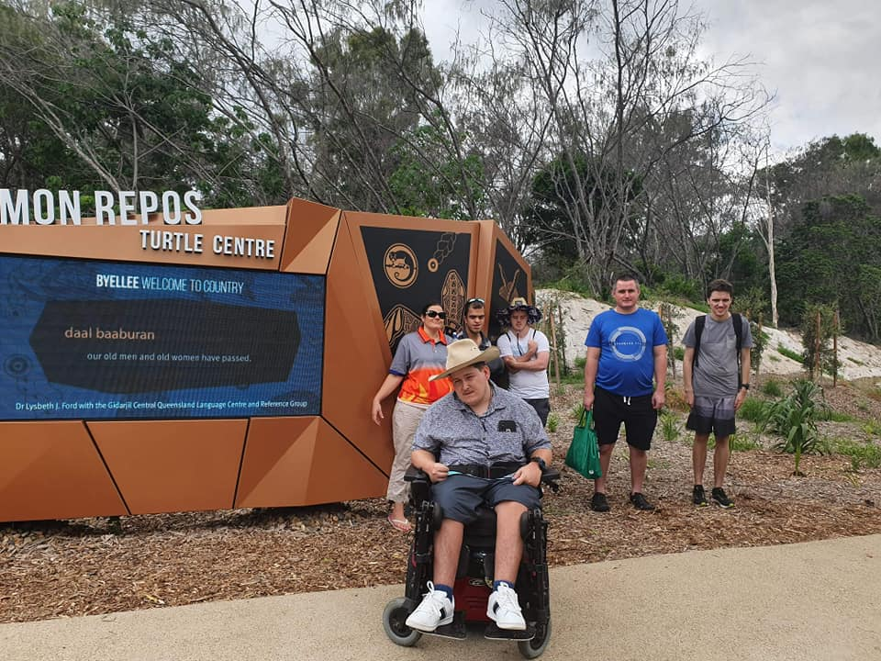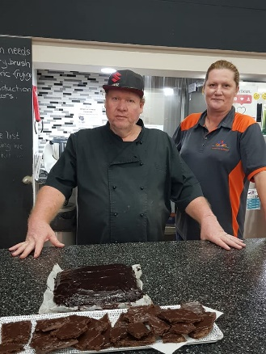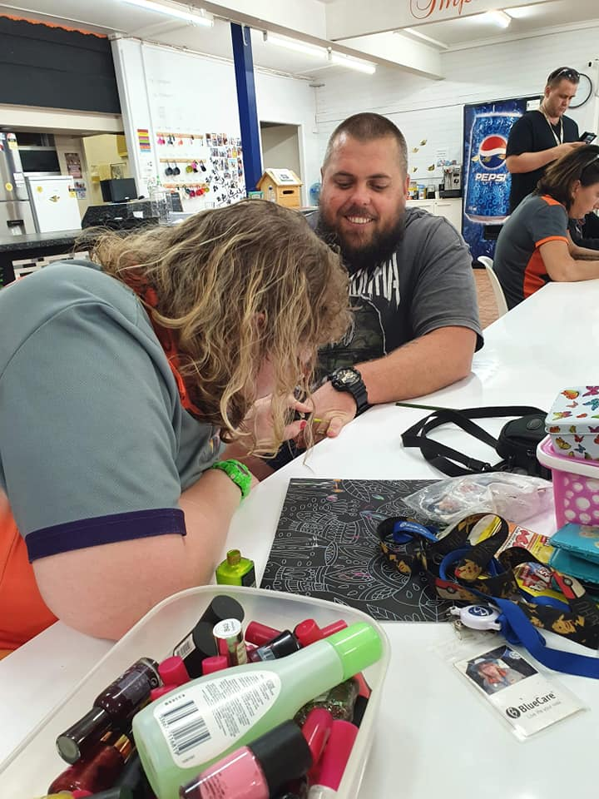
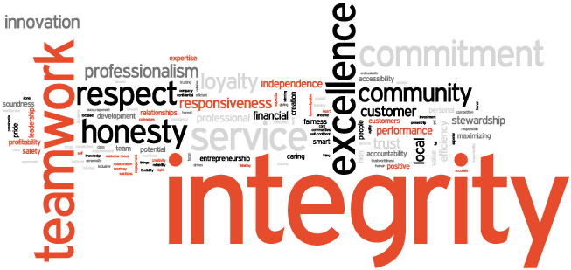

Our Values
Integrity - We are committed to a culture of honesty, accountability, transparency and justice
WE ARE -Compassionate
We are determined to ensure our actions improve quality of life and a sense of belonging

We advocate for inclusive communities that support
participation and access Equality

We are committed to innovative ways of supporting and engaging

We embrace opportunities
to build alliances that strengthen our capacity
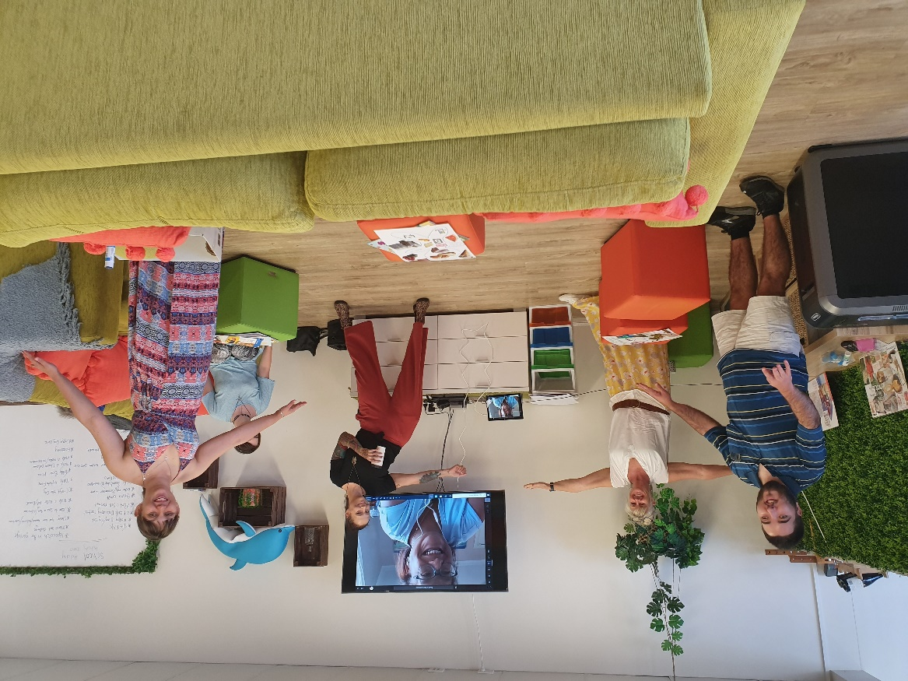Our Values
Integrity - We are committed to a culture of honesty, accountability, transparency and justice
WE ARE -Compassionate -We are determined to ensure our actions imp
We provide an understanding, professional and empathetic service to people of all ages and abilities. We ensure our participants are treated with respect and dignity while enjoying the lifestyle of their choice.
Our programs are designed to support people in their life’s journey with all the ups, downs, twists and turns that the journey can present.

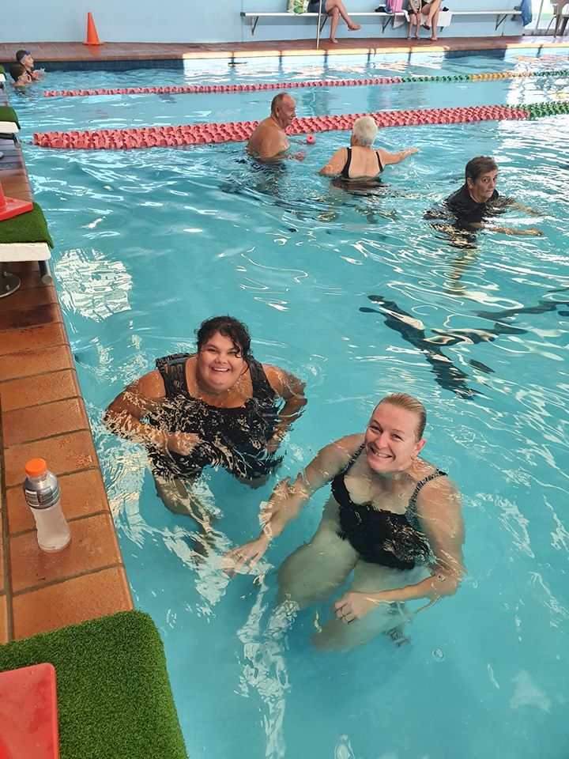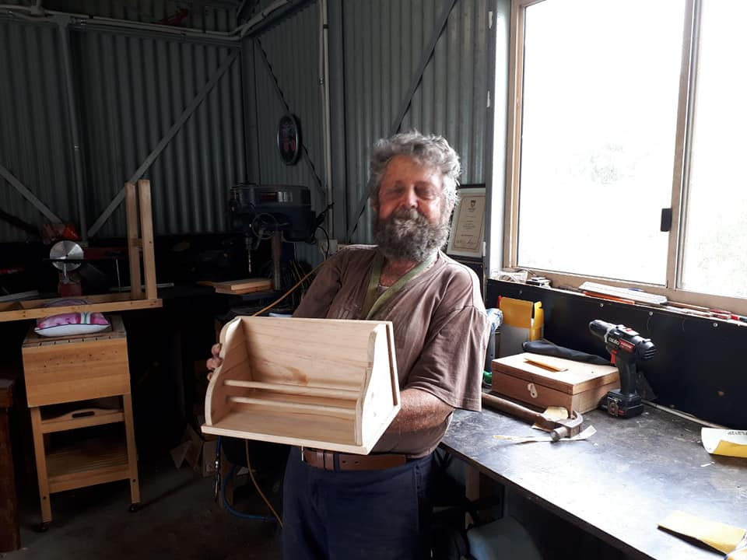Access to our programs and activities
Our door is always open and we welcome enquiries about how our programs can be of help. NDIS is the new national entry point into the disability system. Our staff can explain the process and assist you to navigate these new systems if you need support or information.
Our services are participant-focused and aim to support you to achieve your personal goals, remain living independently and involved in your community. You can connect with us through joining one of our many community-based activities or talk to us about how our services could help with the challenges of living with a disability, staying mentally well or getting through those hard times.

Assessing your needs
Our programs have differing eligibility criteria which may relate to the area you live in, your age or your circumstances.
One of our client liaison officers will work with you to identify your needs and to determine how we can best help you.
We respect your right to decide what’s best for you. You can be assured that your privacy and confidentiality will be respected and that enquiring about or receiving our services will always be your choice.

How are we funded?
We are a registered not for profit charity organization and funding for our programs come from a variety of sources, including State and Federal government funding. We generate funds through our own enterprise activities and through fund-raising, donations and bequests. We also receive significant in-kind support from our volunteers who contribute time, passion and expertise.
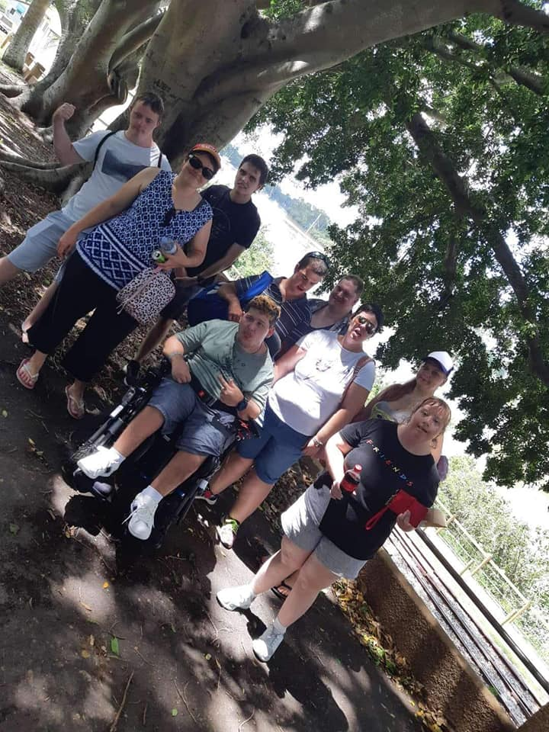

Our Team
Our dynamic and diverse team of staff and volunteers offers highly skilled and professional support to you.
We carefully select our staff, recognizing the need to have professional skills balanced by life skills. We are passionate about our work, and we will take every opportunity to collaborate with you around your needs. IDSS embraces opportunities to train our staff and volunteers to ensure that we bring the latest knowledge and skills to our workplace. We are a highly mobile workforce; able to access you and move in and around our community.

What makes our service different?

We put you first
Our aim is to provide you with the standard of support we expect for our own families. This means valuing the unique qualities of each participant and seeing the whole person, not just a list of support needs.

Our services are flexible and respond to your changing priorities and needs. We work together with families to keep our customers in control of their own care as far as they are able. That’s why we always listen carefully to what you tell us about how you want to receive your support.
We keep in regular contact, so that you soon get to know the whole team at IDSS. Building a relationship that you can trust and rely upon is central to how we manage our business.
Our programs are designed around your interests and skills and provide an opportunity for you to develop new skills and have new experiences. You will have a CLO and team of mentors
who will work with you to develop your individual program that provides you with a meaningful life.

Become a member of our participant focus group which meets regularly to review and discuss our programs and make suggestions for improvement.

NDIS plan management

Your approved NDIS plan gives you choice in which services you will use to help achieve your goals. Depending on how your NDIS funding is managed, you may be able to use registered providers, unregistered providers, or even directly employ your own staff to help you reach your goals.
Services may come from a person, business or organisation.
There are different ways to manage your NDIS funding.
The different options are: 1. NDIA managed (also called Agency managed)
2. Plan-managed
3. Self-managed
4. A combination of the above three management types.

Plan management allows you to:
- have choice and control over the providers you use;
- use NDIS registered providers;
- use non-registered providers (although your Plan Manager must be a registered provider);
- negotiate pricing to pay less than the NDIS price guide;
- make value for money decisions in line with your plan;
- view your plan on the myplace portal to keep track of your budget

Role of the Plan Manager

If you choose to be plan-managed, a Plan Manager is funded in your plan and must be an NDIS registered provider.
They claim directly from the budgets in your plan to pay your providers on your behalf.
If you choose to use IDSS as your Plan Manager, we will:
- pay your providers for the supports you purchase;
- help you keep track of your funds;
- take care of financial reporting for you;
- depending on your circumstances, they can also help you choose your providers.

Our Programs
Building YOUR Independence
All our programs have at their heart a commitment to providing the assistance that can help people achieve their goals. It could be that you need a lift to the shops, some help around the home, a structured exercise program, or maybe help to join a social group. Our services are designed to support you with the help you need at the times you need it.
We connect people to their community through a broad range of social activities focusing on developing community linkages. We can also assist people to attend appointments, to access their local shopping Centre and to continue engaging in everyday activities.
The support of health care professionals in the areas of Exercise Physiology and Community Nursing services are also available. These services can assist with medication reviews, safety in the home, cognitive and functional assessments as well as advice on how to access increased assessments and services.
Our programs promote wellness and continued independence in the community and we work with a range of specialists, groups and programs that can improve your overall health and support needs.

Domestic Support
Some people may find managing their household duties difficult without support. IDSS Domestic Support helps participants manage their household and domestic duties. Dependent on an individual’s needs and circumstances, we provide services that will assist with cleaning, shopping and other light home duties. This assistance can mean that people can remain living comfortably in their own homes within our community.

Short term accommodation – Respite
While caring for a loved one is a rewarding experience, it can also be daunting and often unexpected. Also known as ‘short-term care’, respite is a form of support for carers, which allows them to take a break from their caring duties while ensuring peace of mind that their loved one’s care needs continue to be met by health care professionals.

The IDSS Difference:
At IDSS we like to do things differently. As a private respite service, we aim to deliver a more personalised respite experience, allowing care requirements and personal preferences to take priority.
- Participants remain in control over how and when care is delivered
- Lifestyle mentors are available onsite 24 hours per day
- Respite can be provided in your own home or at one of our partner locations
- IDSS Respite includes all meals, outings and activities, as well as lifestyle and diversional therapy programs if requested.

Home Assist
We offer practical help and information for all your home maintenance. Home Assist can help you with managing those jobs around the house, this might include developing a regular cleaning or yard maintenance schedule or just learning how to change a lightbulb. We can also assist with complex issues such as a cluttered home environment and can assist people who struggle to keep things organized to develop a plan.
This program supports people who live with a functional disability or mental health challenges who require assistance to stay on top of routines and household chores. The domestic team work alongside each person to develop skills and increase independence. We assist people to set goals, organize, and clean their living areas and to maintain a safe and hygienic home environment.

Life Skills

We work closely with our local community and other services to provide opportunities for social interaction, community involvement and vocational choices. Our inclusive engaging programs aim to develop life skills, responding to individual’s aims and aspirations.
We offer you the opportunity to learn how to live more independently by promoting experiences that include:
- Cooking – including meal planning, shopping and creating tasty delights
- Home care skills
- Healthy life choices programs focusing on fitness and nutritional awareness
- Budgeting
- Relationship building activities

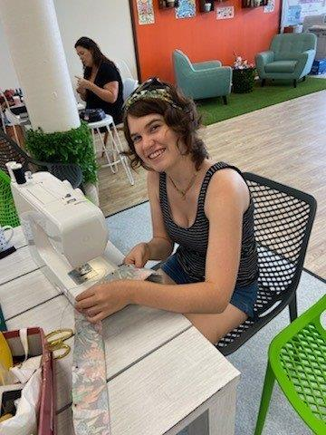
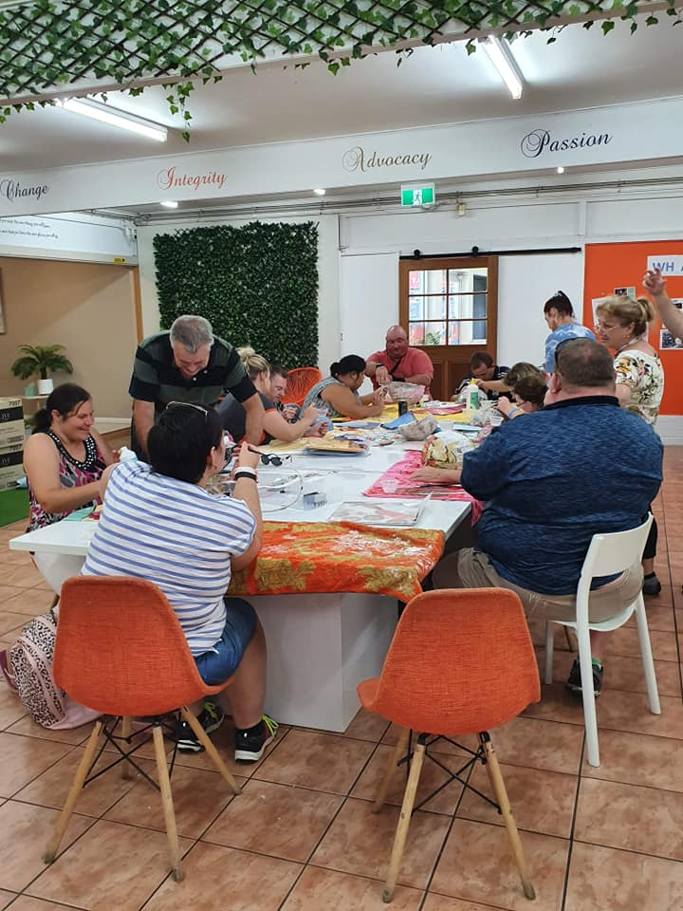

Community Centre Hub – IDSS HQ
A day at HQ provides you with the opportunity to enjoy a day away from home. Our beautifully renovated Centre provides a welcoming atmosphere with social activities and regular information sharing events and workshops.

Our team of mentors work to support our participants and their individual needs and will ensure the day’s activities are stimulating and interesting for all.

Offering cooking classes, art and craft groups, health and fitness, pamper sessions and gaming activities just to name a few there will be sure to be something to keep you busy.

Mental Wellbeing

IDSS’s Mental Health Support Service encompasses social support and domestic assistance programs that provide practical assistance that enhances individuals’ daily lives. The program supports people to set goals and to manage the routines of daily life and to access the community for appointments and recreational activities.
Our team of mentors offer flexible, inclusive and creative supports that respond to the needs of people experiencing functional disabilities and mental health challenges.
Physical, psychological, emotional and spiritual needs of individuals and their families are considered to ensure all needs are met. We also provide advocacy, information and linkages to ensure the best possible supports are engaged for each person in the program.
Through the broad range of inclusive recreational activities, we support people to connect with others, have fun and access the local community by helping them to overcome social isolation and increase their connections to the community.

Participants are supported through a recovery focused and strengths based approach that recognizes recovery as a personal journey driven by the participant. Our mentors provide practical assistance to people with severe mental illness to help them achieve their personal goals, develop better relationships with family and friends, and manage their everyday tasks.
One-to-one and ongoing support ensures the individual needs of our participants can be addressed. Participants are assisted to access services and to participate economically and socially in the community, increasing their opportunities for recovery.
IDSS offers both one-to-one support as well as a number of group activities that aim to develop people’s skills in managing mental illness and/or increase community participation.

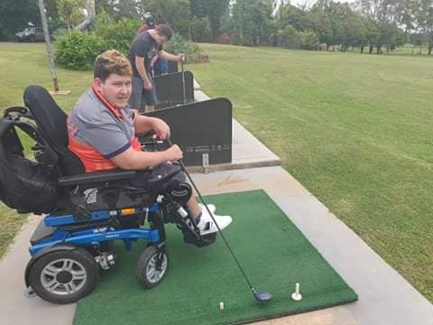

Outdoor and Exercise

Do you love to go dancing, go for a walk or swim at a pool? We can help you with your outdoor exercise activities. Offering support to develop individualised recreational interests, whether it be an activity you like to do at home, attending a gym or joining in one of our group exercise programs we will tailor a program based on your interests, goals and abilities aimed at supporting you to live an active and fulfilling life. Our accredited exercise physiologists and personal trainers are here to help you achieve your goals.

Social and Leisure

Shopping – Movies – Shows - Your social life will never be the same again! Supported by your IDSS mentor - whether it be getting together with other people, attending a club or supporting your local footy team on a Saturday afternoon we will support you to access your community. Going to the markets, visiting local attractions or events, or simply visiting the library, IDSS will assist you to enjoy your interests.
If using an iPad, listening to music, going fishing or arts and crafts are your thing – then it is ours too.

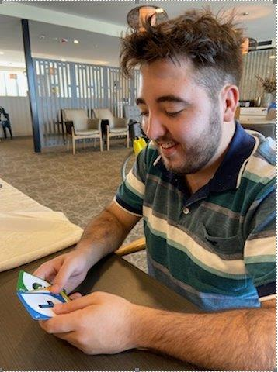

Holiday planning

Fancy a holiday? Need some help to make it happen? No problem!
IDSS can assist with your arrangements and where possible provide a mentor to go with you or help to arrange support at your destination.

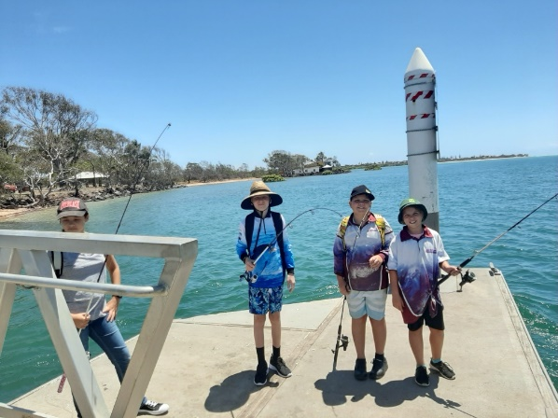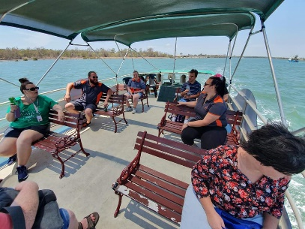

Cultural and Religious

Your cultural and religious choices are respected by all at IDSS and you will be supported to participate in any events relevant to you. As a non-denominational organization, diversity is embraced and we are respectful of and committed to accommodating your beliefs and cultural values.

Getting Involved in Your Community
Volunteers
Volunteers assist us and bring essential support to all our services. Volunteers’ talents and interests are considered and matched with individuals needing support and services requiring expertise. IDSS volunteers offer their time to drive people to appointments, make friendly home visits, and contribute to everything we do at IDSS HQ.

Community Development
We advocate for inclusive communities that support participation and access.
We embrace opportunities to build alliances that strengthen our community and we offer support to individuals and community groups to grow and develop ideas and initiatives. We work with local community groups offering support with projects, activities and ideas for enriching our community.

Community Education - Low-cost opportunities for people in our community to come together around shared interests and activities.

Our groups and classes aim to support a healthy and active community. All activities are provided by local people with passion and expertise and offer informal and affordable opportunities for people to participate in physical activities, creative classes, conversation groups, support groups and personal development workshops.

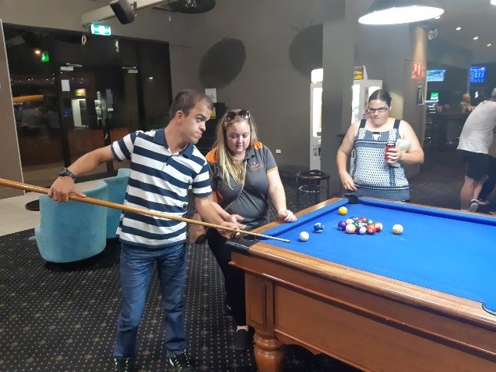

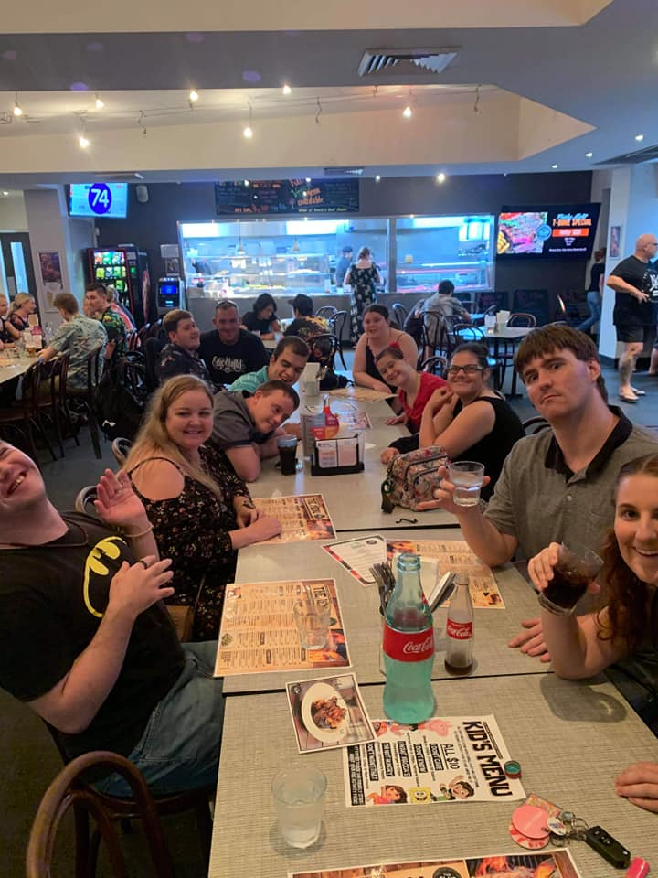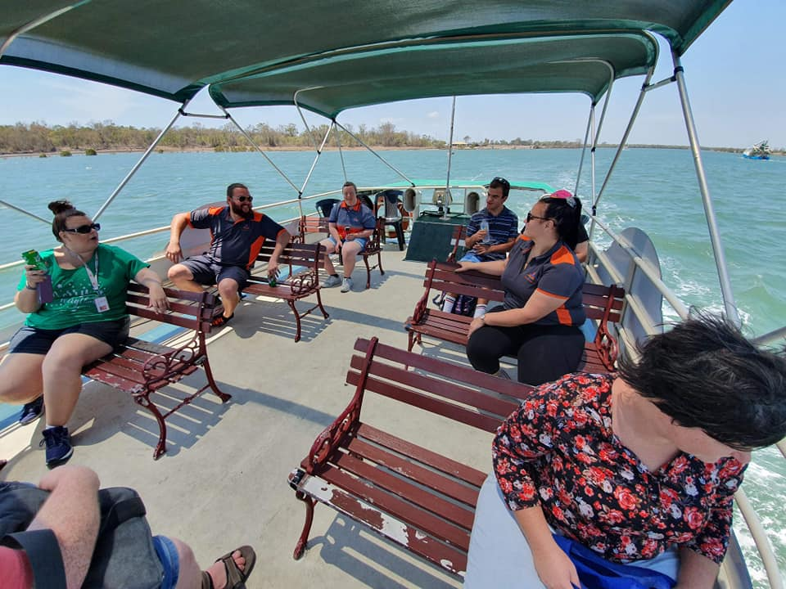

Carers
It’s important to feel supported when you are caring for someone and you may need some time to yourself or to talk to someone who can help.
Carers are always welcome to call in to IDSS HQ to talk to one of our friendly staff members or just have some time out. IDSS will host regular forums and workshops for our carers to share information and develop relationships.
Advocacy
You may wish to appoint an advocate to assist you with negotiating your requested service and support:
- An advocate is a person who, with authority from yourself or your family, represents your interests
- An advocate may be a family member, friend, or a person from an advocacy service such as Queensland Aged and Disability Advocacy (QADA) on
(07) 3637 6000
- You have a right to change your advocate at any time
- Advocates may be used during assessments, reviews and complaints, or for any other communication between you and IDSS.

Do you need an interpreter?
Please discuss your need for an interpreter with us or call:
Centrelink Officers on 131 202
Translating and Interpreting Service 1800 131 450
Should you wish to change the way in which we work with you, or request an advocate to support you, please let us know.

Complaints process

Any complaints made in relation to access and equity issues will be brought to the immediate attention of management. Complaints will be handled in line with the IDSS Participant Complaints Policy. The complainant will be continually informed at each stage of the progress.

People of a Culturally and Linguistically Diverse Background

In cases where an individual does not speak English, an interpreter service should be used to ensure that the Participant understands the assessment and review process, the services being offered, the Individual Support Plan and the general information provided in the Participant Handbook.

The need for an interpreter service should be clearly identified on the participant’s file.

Indigenous People

IDSS will endeavour to provide Aboriginal and Torres Strait Islander Participants with culturally appropriate services and where possible and appropriate, these services are to be delivered by Indigenous staff. Staff should ensure that the information regarding the assessment, review, Individual Support Plan and services are available in culturally appropriate formats and are clearly explained to and understood by the Participant.

People who cannot read or write

In cases where a Participant cannot read or write, staff should ensure that the information in the Participant Handbook and the information regarding the assessment, review, Individual Support Plan and services are clearly explained and understood by the Participant.

Other special needs groups

Employees will receive training in how to deal with people with specific disabilities. Every effort will be made to ensure that services are delivered in an appropriate and sensitive way.

Charter of Rights & Responsibilities

IDSS aims to uphold the rights of people with disability, including the right to dignity and respect, and to live free from abuse, exploitation, and violence. This is in keeping with Australia’s commitment to the United Nations Convention on the Rights of Persons with Disabilities.
IDSS will achieve this through:
- empowering people with disability to exercise choice and control in the support services they receive, while ensuring appropriate protections are in place
- building the capacity of people with disability, their families, and their carers to make informed decisions about NDIS supports
- responding to and managing concerns and complaints

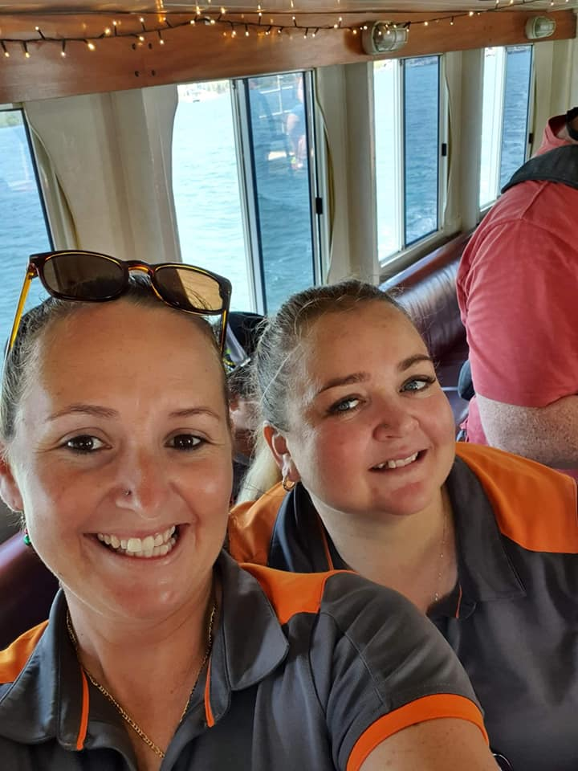

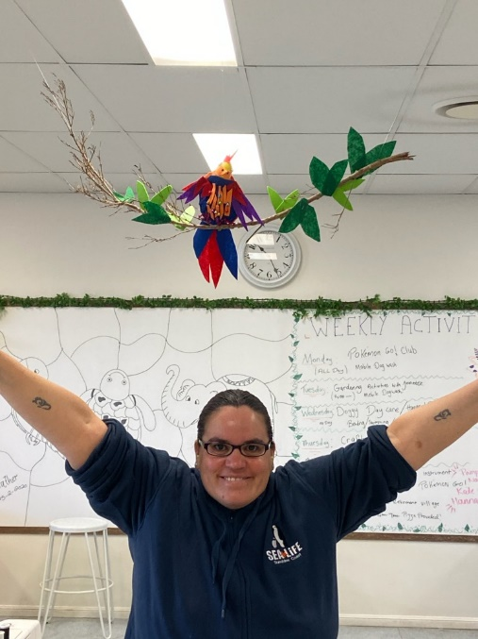

Charter of Rights
As a support recipient, I have the following rights:

- General
- to be treated and accepted as an individual, and to have my individual preferences respected
- to be treated with dignity, with my privacy respected
- to receive support that is respectful of me, my family and home
- to receive support without being obliged to feel grateful to those providing my care
- to full and effective use of all my human, legal and consumer rights, including the right to freedom of speech regarding my support
- to be treated without exploitation, abuse, discrimination, harassment or neglect

- Participation
- to be involved in identifying the support plan most appropriate for my needs
- to choose the support and services that best meet my assessed needs, from those able to be provided and within the limits of the resources available
- to participate in making decisions that affect me
- to have my representative participate in decisions relating to my support if I do not have capacity
- Support and services
- to receive reliable, coordinated, safe, quality support and services which are appropriate to my assessed needs
- to be given before I commence receiving support, a written plan of the support and services that I expect to receive
- to receive support and services as described in the plan that take account of my lifestyle, other care arrangements and cultural, linguistic and religious preferences
- to ongoing review of the support and services I receive (both periodic and in response to changes in my personal circumstances), and modification of the support and services as required
Personal information
- to privacy and confidentiality of my personal information
- to access my personal information

Communication
- to be helped to understand any information I am given
- to be given a copy of the Charter of Rights and Responsibilities
- to be offered a written agreement that includes all agreed matters
- to choose a person to speak on my behalf for any purpose

Comments and complaints
- to be given information on how to make comments and complaints about the support and services I receive
- to complain about the support and services I receive, without fear of losing the support or being disadvantaged in any other way
- to have complaints investigated fairly and confidentially, and to have appropriate steps taken to resolve issues of concern

Fees
- to have my fees determined in a way that is transparent, accessible and fair
- to receive invoices that are clear and in a format that is understandable

Responsibilities
As a participant of IDSS services I have the following responsibilities:

General
- to respect the rights of support workers to their human, legal and industrial rights including the right to work in a safe environment
- to treat support workers without exploitation, abuse, discrimination or harassment

Care and services
- to abide by the terms of the written agreement
- to acknowledge that my needs may change and to negotiate modifications of support and service when my care needs do change
- to accept responsibility for my own actions and choices even though some actions and choices may involve an element of risk.
Charter of Rights & Responsibilities (continued)

Communication
- to give enough information to assist the approved provider to develop, deliver and review a service agreement
- to tell the approved provider and their staff about any problems with the support and services

Access
- to allow safe and reasonable access for support workers at the times specified in my service agreement or otherwise by agreement
- to provide reasonable notice if I do not require support

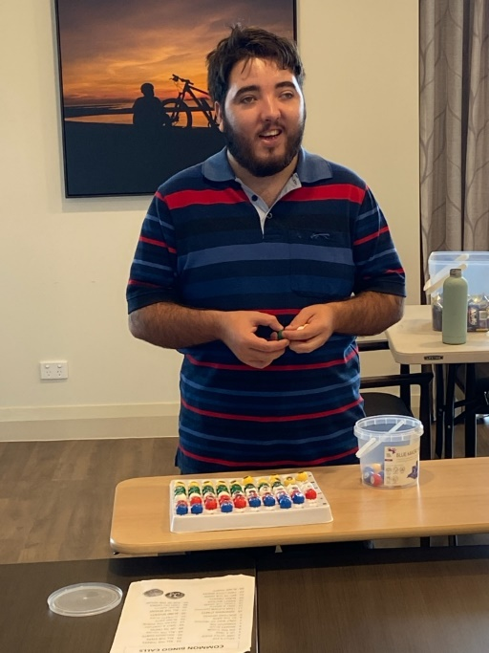
Fee
- to pay any fee as specified in the agreement or negotiate an alternative arrangement with the provider if
any changes occur in my financial circumstances
- to provide enough information for the approved provider to determine an appropriate level of fee

Privacy & Confidentiality
In accordance with the Privacy Act 1988 (Cth), IDSS has created a Privacy Policy which outlines: how personal information is collected, the kinds of information collected, what the personal information is used for and how the personal information is stored and managed.
We take our privacy responsibilities seriously and we aim to ensure our practices fully comply with relevant legislation.
IDSS respects your privacy and must comply with legislation when it comes to the way in which we collect, use, disclose, access, transmit and dispose of any personal and health information we hold about you.
Our Privacy Policy is available on our website or by request.

Compliments, Suggestions or Complaints
We rely on your feedback to improve our services. We thrive on compliments so please do tell us if you are happy with the service you’ve received or let us know how we could do things better. Please also let us know if you’re not happy and you’d like to make a complaint.

Our Complaints Process
- Talk to your usual staff member to see if you can come to a resolution.
- If there is no solution you can contact the coordinator of your service who can help with coming to a resolution.
- If you still have unresolved concerns, you can ask to speak to any one of our senior management team. They will get in touch with you within 5 working days of receiving your complaint.
- If you are still not satisfied, your complaint will be referred to the Chair of our Board of Management who will respond to you within 10 working days of receiving the complaint.
- If you are still not satisfied with the response you are then able to seek advice from outside of the organization.

